

Mobil Producing Nigeria Unlimited

Bilabri D2

COMPLETION INSTALLATION
RECOMMENDATION

Revision: 1 March 13th, 2007

Prepared By: Adesina Adeyeba Phone: 01 461 8845 / 0059 / Mob 08053492022

TABLE OF CONTENTS

SECTION

WELL INFORMATION 1.0

PROCEDURE 2.0
Completion Recommendation

The recommendations contained in this proposal are submitted in the best interest of the Operator and the Supplier. These designs are based on the information available at the time of writing and are subject to further analysis
1.0 WELL INFORMATION
Casing Size & Weight: 9 5/8”, 47# N-80 BTC
Workstring Size and Weight: 5.00” Drill Pipe
Production Tubing: 4 ½’’ Vam Top
Completion Fluid:
Packer Fluid:
Customer Representative: Ray Ismail
Customer Phone/Fax: 08034600125
Rig / Co. Rep.: Bulford Dolphin
Rig Phone/Fax:
Loadout Point: Port Harcourt
Disp./Dock Phone:

1.1 PRODUCTION INTERVAL – SAS
Reservoir Name: C1 Sand
Reservoir Type: Oil
Horizontal Interval: 2784 – 3422 meters MD
Deviation @ Zone: 89º
Reservoir Temperature:
Perforation Density: N/A
Est. Reservoir Pressure:
Production Screen: 6 5/8” NK3SB 24# L-80 225 micron ResFlow Screens
Blank Pipe: 5 1/2” Vam Ace 24# L-80 Blank

2.0 COMPLETION PROCEDURE RECOMMENDATION
This procedure assumes the completion fluid system is in place and wellbore clean up has been done. The completion plan for this well involves running and setting 6 5/8” screen on a retrievable seal bore packer in 9 5/8” casing. The well is to be completed as an oil producer with 4 ½’’ Vam Top # tubing string with 6” molded seals located in the retrievable seal bore packer.
Make Up and Running of Screen and Packer Assembly

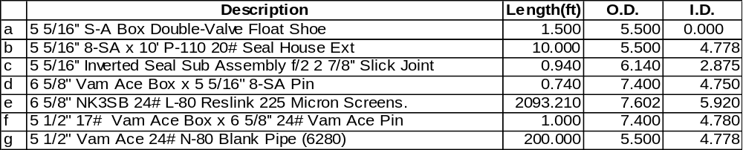MU and RIH with screen and blank assembly consisting of:
Note: Caliper and check tool connections, screen gauge, and record all lengths
Hang off screen and blank assembly with screen table and plate handling system.

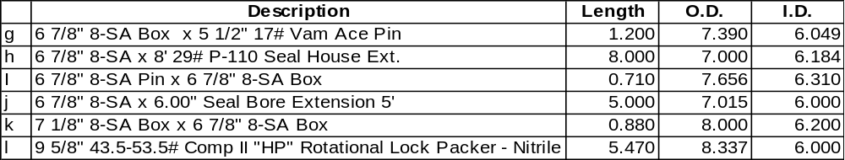PU BJ Services Comp-Set II HP Packer assembly consisting of:

Connect screen and blank assembly to packer assembly. Also connect the packer assembly to workstring and RIH with entire assembly slowly.
Notes:
Ensure all shear pins are in position and the setting sleeve connections are tight. Caliper and check tool connections, and record all lengths.
Handle packer with care, flush the ID with water to ensure nothing is obstructing the ID. Drift workstring while tripping in the hole and have only one drift on the rig floor and do not rabbit any tubing over rotary table. If necessary, sparingly use dope on the work string, pin ends only. Torque all connections to the recommended torque.
Always cover the hole whenever working above the rotary table.

RIH with entire assembly at a moderate speed not faster than 30 feet/min, gently loading and unloading slips
- At the 9-5/8" casing shoe, take slackoff and pickup weights.
- Break circulation with 5 bbls to ensure ball seat is clear of debris.
- RIH with assembly to bottom of 8 ½” horizontal open hole at (3422 m). Gently tag bottom of hole and pickup 5ft. Crosscheck to ensure that packer is not across a joint in the 9 5/8” casing and spaceout accordingly.
Packer Setting Procedure

With the packer assembly in place and the tubing full, drop 2 1/4" steel ball, which will fall approximately 250 feet per minute, if the ball has to be pumped onto the seat do so with 1 – 2 bpm maximum. Allow sufficient time for ball to seat.
- Check the OD of the setting ball and verify that it is the correct size for the application.
- Check that the setting ball will pass through all lines and tools that it must fall through when being dropped down the workstring.(This step would ideally be accomplished long before this stage in the procedure)
- Allow 4 minutes for every 1000-ft of measured well depth for the ball to fall to bottom before applying pressure to the ball.
- Place the annulus on the trip tank and monitor well for losses. Ensure the annulus and the workstring remain full while allowing ball to fall.

With ball on seat, pressure up on tubing slowly in 500 psi increments to 2600 psi:

At +1000 psi (890 psi to 1210 psi) the setting sleeve has been activated and the packer will start to set.

At +2600 psi (2200 psi to 3000 psi) the setting sleeve on the setting tool has been sheared, the tool de-activated and the packer will be set. Bleed tubing pressure to zero psi. Pull about 10,000 – 15,000 lbs on the packer to test that the slips are anchored.
Option:
The Packer may not be re-engaged after releasing from it. In an emergency, the SRTS Non Rotational tool can be released from the Packer with 7 to 9 turns of right-hand rotation. Place the workstring in neutral or the least possible tension when releasing with rotation.

Position workstring with neutral weight and test packer with the rig pump by pressuring up and test on the annulus to 3,000 psig for 10 minutes (At 1500 psi the service tool will be released from the packer). Bleed the annulus pressure to zero psi.
- Snap out of packer and pick up ±8’. Pressure the drill pipe to 2600 psi (2200 psi to 3000 psi) to blow the ball seat, which will allow circulation through the work string. After shearing, bleed the tubing to 0 psig.
- Establish circulation rates. Mix and pump displacement pill & ppg FSW. Displace well and monitor returns until clean ppg FSW is received in the tanks. Clean well until NTU’s plateaus at less than 150.
- POOH with packer running/service tool assembly.

Running Production Tubing Assembly

RU to run the production assembly. PU and RIH with the following production tubing assembly and hang off at rotary.
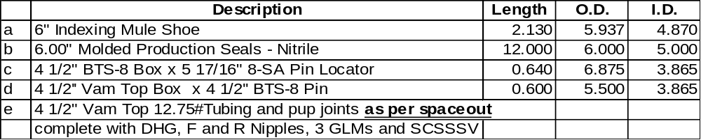Production Tubing Assembly

RIH with entire assembly and install production equipment as per BJ Space-out schematic drawing.
Note: Caliper and check tool connections, all ODs and IDs and record all lengths. Rabbit all tubulars while RIH. Have only one rabbit on the rig floor and do not rabbit anything near well bore. Running speed should not exceed 90ft per 60 sec.

After tagging the Comp-Set II HP packer at +2712.24m with the 6.00” indexing mule shoe, continue to slack off another 14 feet for the locator to locate the top of packer. Pick up 2 ft and mark the drill pipe at the rotary table.

Test packer on the Annulus to 1000 psi for 10 minutes, check if there is return, then bleed off pressure.

Space out tubing, install hanger, cycle SCSSV and leave in open position. Circulate packer fluid (remain below 500 psi while circulating). Land tubing.

